York Pirates! Instruction Manual

*Amended by Sea of Geese*

Controls

|  |  |
| --- | --- |
| **Key** | **Control** |
| Up Arrow | Enable forward movement |
| Down Arrow | Stop forward movement |
| Left Arrow | Turn left |
| Right Arrow | Turn right |
| F | Interact with islands |
| Esc | Exit menus |
| LMB | Select button |

Gameplay

**Sailing**

During sailing mode you can use your ship to move between islands. You can also randomly encounter enemy colleges’ ships if you sail around in their territory (the territory you are currently in is displayed at the top of the screen). If you sail to a college’s island you can challenge their boss ship. If you successfully defeat a college’s boss you will take over their territory and will no longer encounter hostile ships there. You will also be able to heal at that college’s island (for a cost).

Some islands house departments rather than colleges. These islands are neutral and so can always be used to repair or even apply unique upgrades to your ship.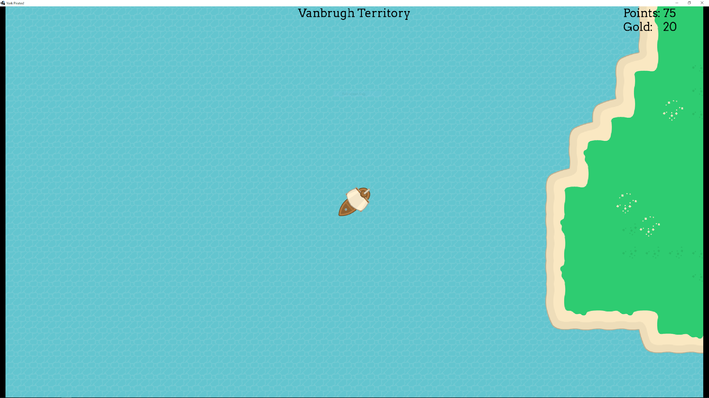

**#**

In neutral territory, sea monsters may be encountered and battled in a similar way to enemy ships.

While in sailing mode, you may be affected by the weather. If you are in a stormy region, this will be displayed on the HUD and you will lose 1 health point per second, but gain 2 points per second.

Initially, there is an invisible wall preventing you from sailing to Goodricke, Langwith, or Computer Science. To get rid of the invisible wall and sail to Campus East, defeat James and Vanbrugh colleges.

**Combat**

During combat mode you are able to select attacks to use against the enemy ship in order to defeat them. You can also flee if you feel you are unable to defeat the enemy. Successfully defeating an enemy ship will reward you with some points and gold.

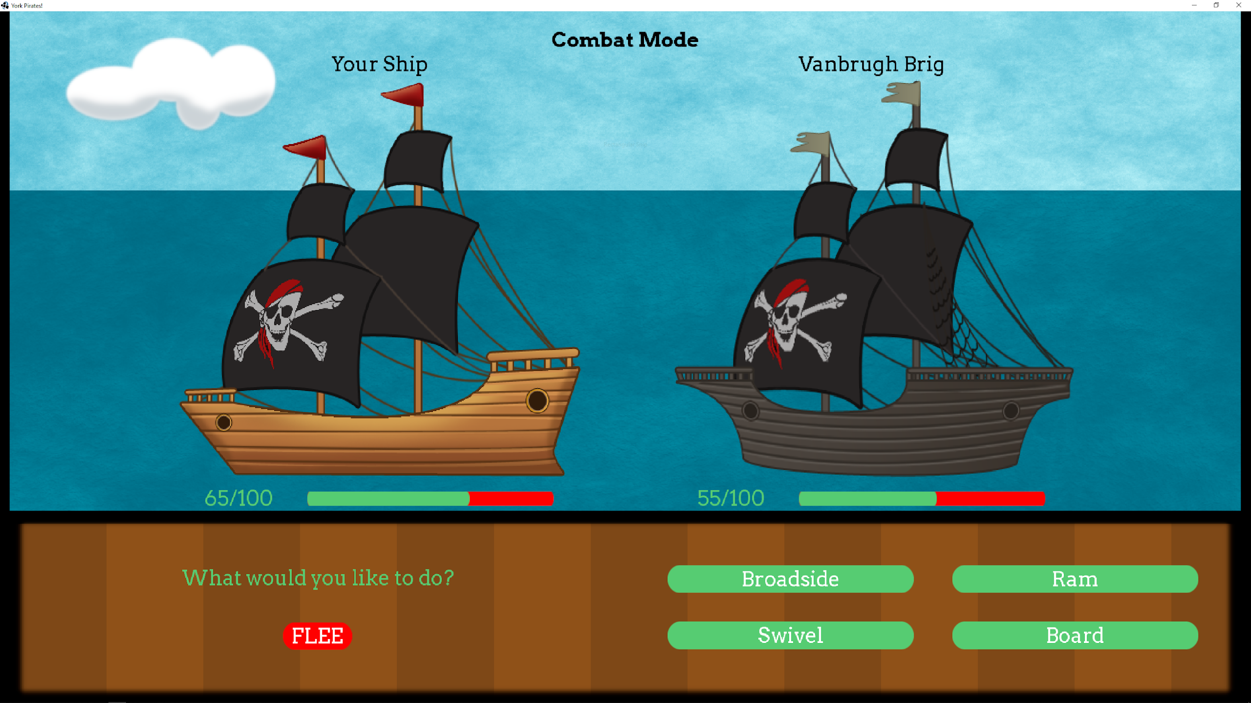

**Minigame**

In the minigame, you can bet 100 gold on the outcome of a race between five geese. If you win the bet, you will gain an extra 100 gold - otherwise, you will lose the 100 gold.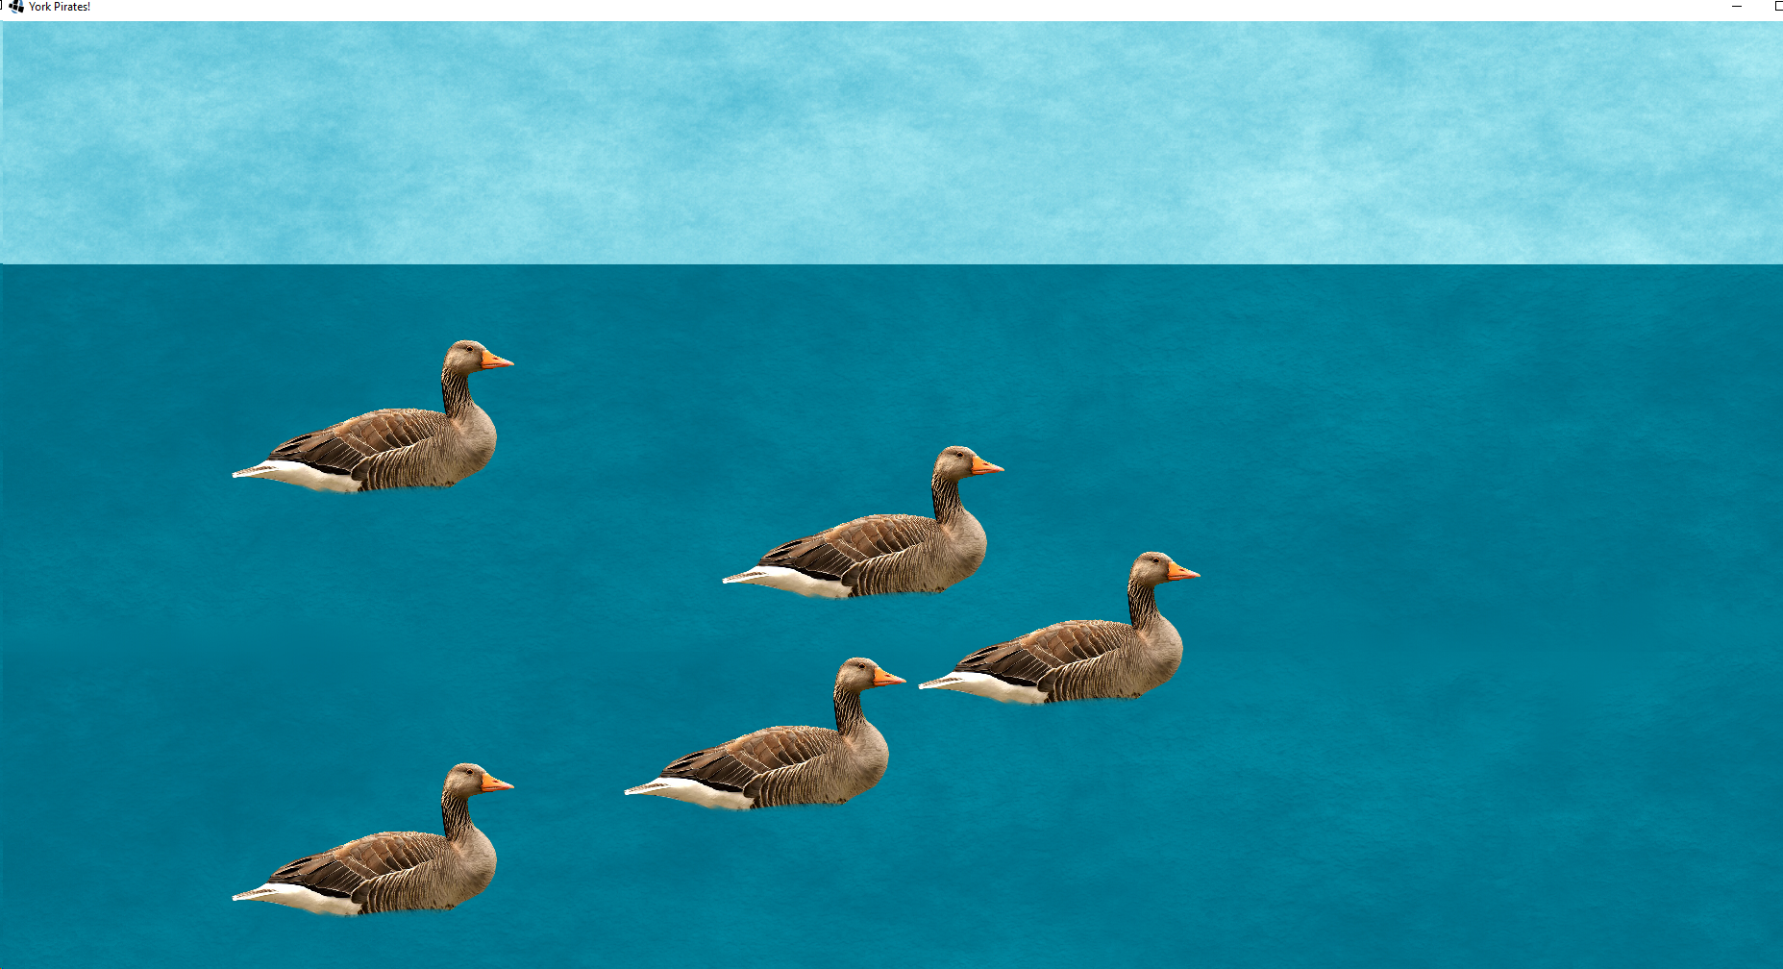

**Winning the game**

To win the game, capture all five colleges.